POC 6
Scaling the Eukaryota Dataset and Measuring
Precision, Recall and F1
Expanding the eukaryota reference set 29-fold, fine-tuning on it, and
evaluating all three kingdoms as a decision system at
1,000 / 2,000 / 5,000 held-out samples
eDNA-TaxAI · 29 September 2026

1. Executive Summary
POC 6 closes the last measurement gap in the project. Three things were done:
- 1. Fixed the eukaryota sample-size problem. Eukaryota's reference set was limited to 853 records, which allowed only 89 held-out test fragments — too coarse to measure anything, since one fragment moved the score by 1.1 percentage points. It was rebuilt to 25,000 records from a pool that had been sitting unused since Part 2.
- 2. Fine-tuned on the new set. A fourth checkpoint was trained on the new 20,000-reference training split, using the corrected recipe from Part 12.
- 3. Measured precision / recall / F1. All three kingdoms were scored as a decision system — precision, recall and F1 on the pipeline's actual commit/abstain output — frozen versus fine-tuned, at three test-set sizes.
The headline result, across 15,000 held-out test fragments in total:
Fine-tuning the embedding model changes the production pipeline's answers by essentially nothing. Net effect across all three kingdoms at n=5,000: +3 correct calls for bacteria, −1 for fish, and 0 for eukaryota — despite the fine-tuned models being 62.1, 35.2 and (previously) 6.7 percentage points better when measured in isolation. For eukaryota, the kingdom with 5,000 fully independent samples, the two arms are identical to four decimal places at every sample size.

This confirms, under proper classification metrics and with 5x more test data, what Parts 13 and 14 found using Recall@K: BM25 retrieves almost every answer the system is capable of finding, and the embedding model — however much better it gets — can only reorder what BM25 already handed it.

2. The Eukaryota Dataset Problem, and the Fix

2.1 Why 853 references was not enough
Part 9 built the eukaryota reference set using Tara Pacific's real 1389F/1510R primers, because those match the actual ERR10928327 seawater reads being classified. That was the correct decision for classifying those reads. But only 865 SILVA records contained that exact primer pair, giving 853 usable references — and after the standard 80/20 split, just 89 held-out test fragments.
At n=89, a single fragment is worth 1.1 percentage points. Any precision, recall or F1 computed on that is dominated by sampling noise, and no comparison between two models could be trusted.

2.2 The unused pool
Part 2 had already extracted the same gene region (18S V9) from the same SILVA database using the standard Earth Microbiome Project primers, 1391F/EukBr. That extraction produced 140,968 amplicons and had been unused since Part 8 sampled 5,000 of them. No new download was required.
Eukaryota source | Primers | Total amplicons | Usable references
Tara set (Part 9, retained) | 1389F / 1510R | 865 | 853
Part 2 pool (now used) | 1391F / EukBr | 140,968 | 55,011 after filtering

2.3 How the new set was built, and what it costs
Two filters were applied, both deliberate and both documented in the code:
- Minimum length 141bp. A reference must be strictly longer than the fragment cut from it. This pool averages only 126.8bp, so without this filter roughly 31% of held-out references yield no fragment at all — which is exactly why Part 8 requested 1,000 fragments and received 505. Filtering up front makes the held-out count exact.
- No ambiguity codes. Reusing the same validation rule every prior stage applied, because the tokenizer crashes on IUPAC ambiguity codes. Dropped 909 records.
The honest cost of the length filter: it selects the longer ~40% of V9 amplicons (55,011 of 140,968), so the new set is not length-representative of the full pool. This is a deliberate trade of representativeness for a predictable, adequately powered test set.
 | Old (Tara) | New (large pool)
Total references | 853 | 25,000
Training split | 683 | 20,000
Held-out split | 171 | 5,000
Max independent test fragments | 89 | 5,000

The new set is registered under a separate key. The Tara-primer table is untouched, so Part 9's real-read results and Part 14's eukaryota numbers remain exactly reproducible — nothing previously reported was overwritten.

3. Fine-Tuning on the New Set
The corrected Part 12 recipe was used unchanged: training pairs are a random 118–140bp fragment matched against its own full reference, labels are instance-level rather than taxonomic, and only the evaluation's training split is used so held-out references are genuinely unseen.
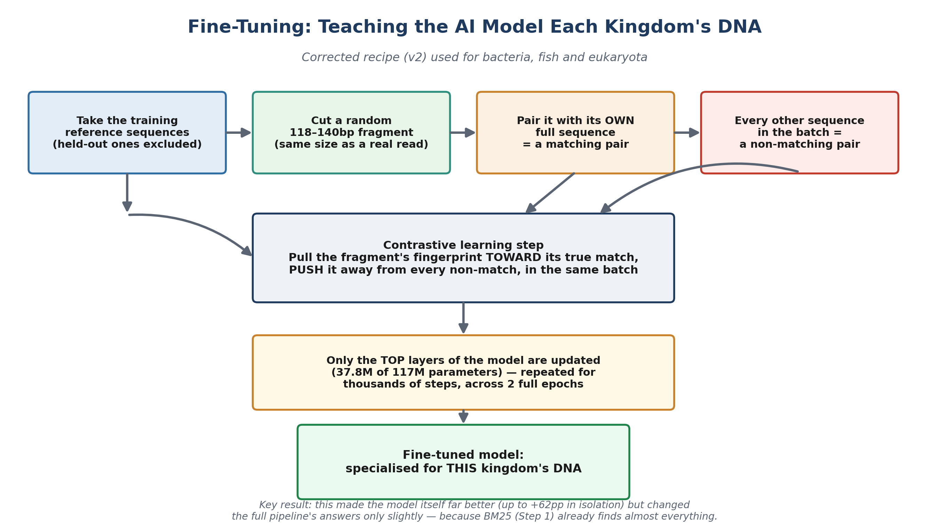
Figure 1. The corrected fine-tuning recipe, applied here to the new eukaryota set.

3.1 Training run
Property | Value
Training references | 20,000
Distinct sequences among them | 9,492 (53% are exact duplicates)
Trainable parameters | 37.8M of 117.1M (top 4 layers)
Steps | 5,000 (2 epochs x 2,500)
Mean loss, epoch 1 → 2 | 0.1236 → 0.0417
Wall-clock time | 110.7 minutes

3.2 A caveat on the low loss
This run reached the lowest epoch-1 loss of any training run in the project (0.1236, against fish's 0.268 and bacteria's 0.746). That is not evidence of superior learning. 53% of the training references are exact duplicates, so a large share of training pairs are byte-identical and trivially easy for a contrastive objective to satisfy.
Part 12 documented precisely this trap: the original bacteria run's loss fell steadily while its retrieval performance collapsed, because collapsing coarse clusters is an easy way to reduce a contrastive loss without learning anything useful. Training loss is not a measure of task performance. The held-out metrics in Section 5 are.

4. How Precision, Recall and F1 Were Measured
Every earlier evaluation in this project reported Recall@K, which asks only whether the correct answer appeared somewhere in a top-K list. That is a retrieval metric. It says nothing about whether the pipeline actually committed to the right answer, or wrongly committed to a bad one. POC 6 scores the thing the pipeline actually outputs.
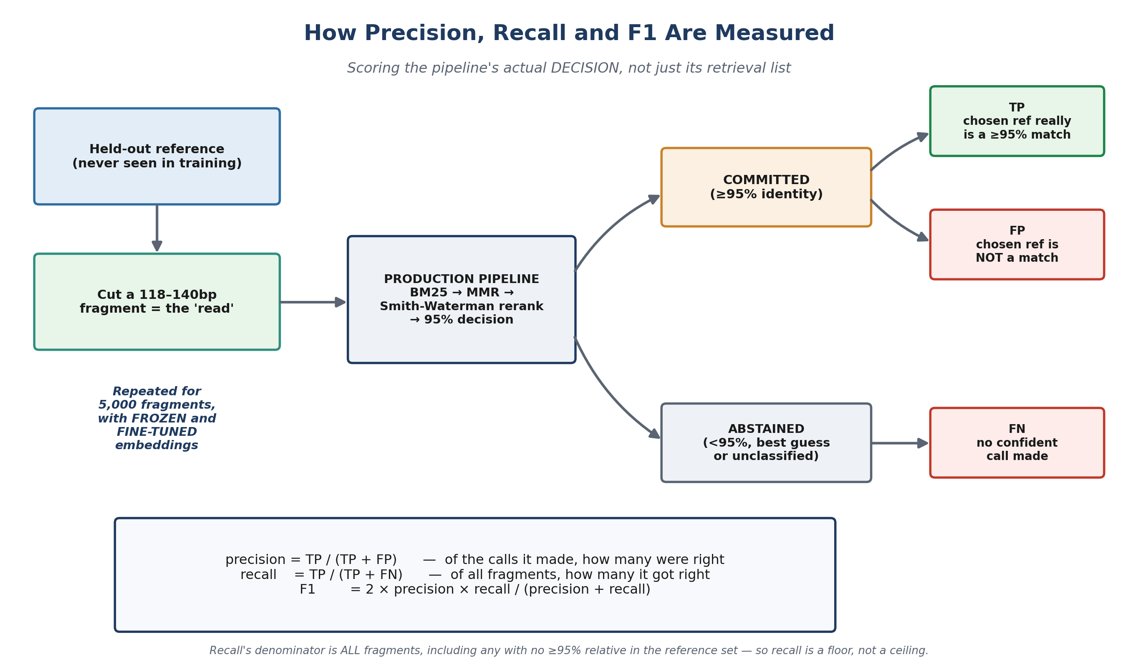
Figure 2. Scoring the pipeline's commit/abstain decision as a binary classifier.
Outcome | Definition
TP | Pipeline committed (≥95% identity) and the chosen reference really is a ≥95% match to the fragment's true source
FP | Pipeline committed, but the chosen reference is not a genuine match
FN | Pipeline abstained — best guess, low confidence, or unclassified
precision | TP / (TP + FP) — of the calls it made, how many were right
recall | TP / (TP + FN) — of all fragments, how many it got right
F1 | harmonic mean of precision and recall

4.1 Design decisions worth stating
- Nested test sets. The 1,000 and 2,000 rows are the first 1,000 and 2,000 fragments of the same 5,000-fragment run, so the three sizes are directly comparable and cost one pass rather than three.
- Recall's denominator is all fragments. Includes fragments whose true source has no ≥95% relative anywhere in the reference set. Those are genuinely unanswerable, so the reported recall is a floor, not a ceiling. Computing true findability would require aligning every fragment against every training reference — 5,000 x 20,000 for eukaryota.
- Identical ground truth. Ground truth uses the same frozen Smith-Waterman ≥95% identity check used throughout the project, so results are comparable to every earlier part.

4.2 Sample independence differs by kingdom
A fragment can only be cut from a held-out reference. Where a kingdom has fewer held-out references than requested fragments, multiple different random windows are cut from the same reference. Those fragments are not statistically independent.
Kingdom | Train refs | Held-out refs | Fragments | Fragments per reference
Bacteria | 4,000 | 1,000 | 5,000 | 5.00
Fish | 13,274 | 3,318 | 5,000 | 1.51
Eukaryota (large) | 20,000 | 5,000 | 5,000 | 1.00 — fully independent

Eukaryota_large exists precisely so at least one kingdom needs no re-sampling. Its results carry the most statistical weight of the three.

5. Results

5.1 Bacteria / Archaea
n | Arm | Precision | Recall | F1 | TP | FP | FN
1,000 | frozen | 0.8989 | 0.8575 | 0.8777 | 782 | 88 | 130
1,000 | fine-tuned | 0.9011 | 0.8578 | 0.8789 | 784 | 86 | 130
2,000 | frozen | 0.9107 | 0.8505 | 0.8796 | 1,570 | 154 | 276
2,000 | fine-tuned | 0.9124 | 0.8507 | 0.8805 | 1,573 | 151 | 276
5,000 | frozen | 0.9119 | 0.8513 | 0.8806 | 3,933 | 380 | 687
5,000 | fine-tuned | 0.9120 | 0.8519 | 0.8809 | 3,936 | 380 | 684

Fine-tuning gains +3 correct calls out of 5,000 (F1 +0.0003).

5.2 Fish
n | Arm | Precision | Recall | F1 | TP | FP | FN
1,000 | frozen | 0.9873 | 0.9474 | 0.9669 | 936 | 12 | 52
1,000 | fine-tuned | 0.9873 | 0.9474 | 0.9669 | 936 | 12 | 52
2,000 | frozen | 0.9832 | 0.9507 | 0.9667 | 1,871 | 32 | 97
2,000 | fine-tuned | 0.9827 | 0.9507 | 0.9664 | 1,870 | 33 | 97
5,000 | frozen | 0.9842 | 0.9501 | 0.9668 | 4,679 | 75 | 246
5,000 | fine-tuned | 0.9840 | 0.9500 | 0.9667 | 4,678 | 76 | 246

Identical at n=1,000; fine-tuning is one correct call WORSE at n=2,000 and n=5,000.

5.3 Eukaryota (large set — fully independent samples)
n | Arm | Precision | Recall | F1 | TP | FP | FN
1,000 | frozen | 0.9989 | 0.9109 | 0.9529 | 910 | 1 | 89
1,000 | fine-tuned | 0.9989 | 0.9109 | 0.9529 | 910 | 1 | 89
2,000 | frozen | 0.9978 | 0.9063 | 0.9499 | 1,809 | 4 | 187
2,000 | fine-tuned | 0.9978 | 0.9063 | 0.9499 | 1,809 | 4 | 187
5,000 | frozen | 0.9963 | 0.9141 | 0.9534 | 4,555 | 17 | 428
5,000 | fine-tuned | 0.9963 | 0.9141 | 0.9534 | 4,555 | 17 | 428

Identical to four decimal places at every sample size — not one call differs.

5.4 Net effect of fine-tuning at n=5,000
Kingdom | F1 frozen | F1 fine-tuned | Change | Correct calls
Bacteria | 0.8806 | 0.8809 | +0.0003 | 3,933 → 3,936 (+3)
Fish | 0.9668 | 0.9667 | −0.0001 | 4,679 → 4,678 (−1)
Eukaryota (large) | 0.9534 | 0.9534 | 0.0000 | 4,555 → 4,555 (0)

6. Correctness Checks
Two independent confirmations that the numbers above are not an artifact of a new, unverified script:

6.1 Cross-validation against the earlier architecture evaluation
The Part 13/14 architecture evaluation is a separately written script that computes 'correct calls' by a different code path. At n=1,000 the two agree exactly:
Kingdom | POC 6 TP (frozen / fine-tuned) | Part 13-14 correct calls (frozen / fine-tuned) | Match
Bacteria | 782 / 784 | 782 / 784 | exact
Fish | 936 / 936 | 936 / 936 | exact

6.2 Train/test separation verified against the training logs
The evaluation reconstructs the seed-42 partition rather than importing it, so the reconstruction was checked against what each model actually trained on. The training reference counts it derives match each model's own training log exactly — fish 13,274, bacteria 4,000, eukaryota_large 20,000 — confirming the held-out references really were excluded from training and the comparison is uncontaminated.

7. Conclusions
- Fine-tuning does not reach production. Across 15,000 held-out fragments spanning three kingdoms and three sample sizes, fine-tuning changes the production pipeline's output by at most 3 calls in 5,000, and in the best-powered case by exactly zero. The isolated improvements (+62.1pp bacteria, +35.2pp fish) are real but do not reach the user.
- The bottleneck is architectural, not model quality. BM25 retrieves nearly every answer the system can find. The embedding model's only remaining job is reordering BM25's own candidates, and it cannot add a candidate BM25 never retrieved. This was already the conclusion of Parts 13-14 from Recall@K; POC 6 confirms it under classification metrics with 5x the test data.
- The pipeline is precision-oriented by design. Precision is high everywhere — 0.912 (bacteria), 0.984 (fish), 0.996 (eukaryota). When the pipeline commits to an answer, it is almost always right. Recall is lower (0.85–0.95) because the system abstains rather than guessing, which is the intended behaviour.
- More data did not change the answer. Larger test sets did not reveal a hidden benefit. Going from 1,000 to 5,000 samples sharpened the resolution and confirmed the absence of an effect rather than uncovering one.

7.1 What is still open
- Could a different architecture unlock the gain? Every architecture tested still takes BM25's 30-candidate shortlist as fixed. Whether widening that pool, or fusing BM25 and embedding rankings earlier, could convert the isolated gains into real end-to-end improvement remains unmeasured.
- Eukaryota duplicate rate. 53% of the new eukaryota references are exact duplicates, so some held-out sequences are byte-identical to training ones. This is not contamination — the records are genuinely held out, and the ≥95% ground truth counts such a match correct anyway — but it makes the task easier than 25,000 references implies.
- Sample independence for two kingdoms. Bacteria (5.00) and fish (1.51) still draw multiple fragments per held-out reference. Their reference pools would need expanding, as eukaryota's was here, for fully independent 5,000-sample tests.
- The new set is not for real-read classification. The large eukaryota set uses 1391F/EukBr primers, which do not match the real Tara Pacific reads. It is the right set for measuring fine-tuning benefit, but the 853-record Tara set remains the correct one for classifying those specific reads.

